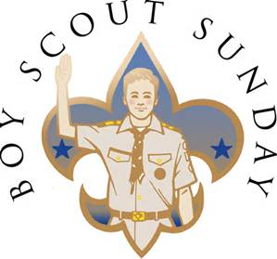
Boy Scout Sunday
February 11, 2018
9:30 Mass
Scouts should arrive 15 min early
Class “A” uniforms for scouts & leaders
Refreshments will be served after the mass
Celebrate Scouting’s 108th anniversary
Please contact
Andy Bodor and Kim Loh Bodor
Akjlb23@optonline.net or 516-996-2297 (Kim)
Bring your Troop/Pack Flag & stand
Please let us know how many scouts & leaders will be attending by Feb 5 so we can have enough reserved seating for your group
Also please bring cookies, cupcake etc. to share
Save the Date: Girl Scout Sunday March 11th

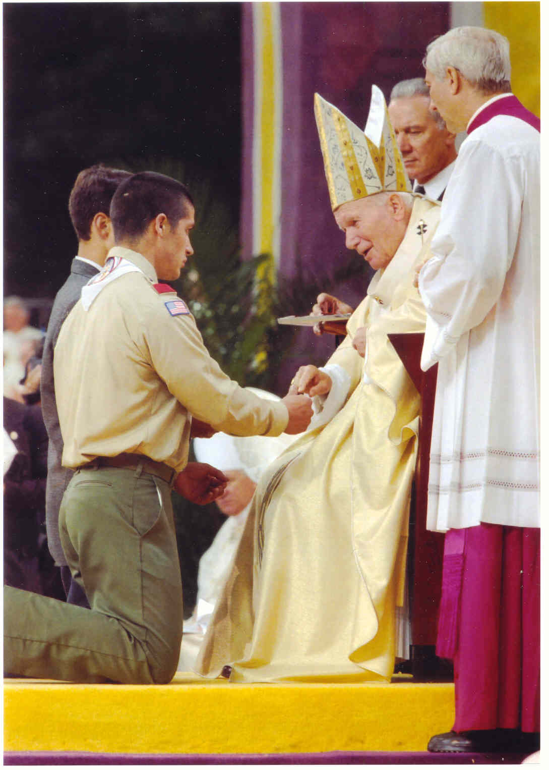 | The Boy Scouts of America annually celebrates its founding on February 8, 1910, based on the program started by Lord Baden Powell in England on August 1, 1907. Scout Sunday was added to the Scout celebration in the middle 1940s. Scout Sunday is always the Sunday preceding February 8th, unless the 8th is a Sunday, in which case the 8th would be Scout Sunday. The Saturday following February 8th is Scout Sabbath.  The Scout Sunday tradition was started to make people in houses of worship aware of Scouting, and to allow Scouts to live out their "Duty to God" pledged each week.  The Scout Law says that a "Scout is Reverent" and the Scouts of all ages promise to do their "Duty to God". These values strengthen youth character in their family, community and faith.  The purpose of this activity is to assist parishes who are not presently celebrating the anniversary of Scouting with their Scouting families and wish to add a "Scout Sunday" service. Parishes who already celebrate the lives of their Scouting families may find the information helpful to enhance their present liturgy.

